COMMISSIONING OF ACE-CEFOR LABORATORY

The Africa Centre of Excellence in Oilfield Chemicals Research is one of the beneficiaries of the World Bank grant in Nigeria. The mission of the Centre is to train both national and international post graduate students with multi-disciplinary expertise in Engineering and Science for sustainable development in the Oil and Gas industry in Africa.
In order to deliver on its mandate, graduate students of the Centre are assisted to have industry experience in their chosen area of specialization from related industries. They are all expected to undergo a one-month intensive internship either with a company or a well-equipped laboratory. This exercise has gone on smoothly till the year 2020 when COVID-19 came calling and work ethics was disrupted. This period affected our students terribly as every industry had restrictions on who was allowed to use their facility. It was in the face of this challenge that the building of dedicated laboratories for the Centre was birthed.
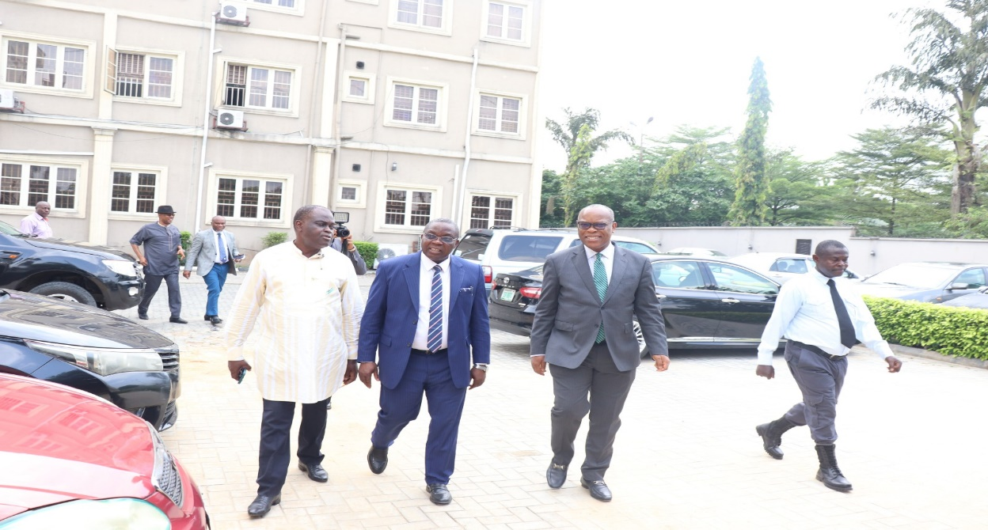
DVC R&D arriving with other Guests for the opening of the Laboratory, Canteen and Baby friendly Centre
CONSTRUCTION OF THE LABORATORIES
The Centre designed and completed two laboratories; Engineering and Science Laboratories. The construction of the laboratories was completed in record time and the equipment for the laboratories which the Centre had purchased earlier on were housed at the Central Instrument Laboratory and the Institute of Petroleum Studies Laboratory. These were relocated back to the newly constructed Centre’s Laboratory.
The laboratories were opened for usage on the 6th of December, 2022 by the Deputy Vice Chancellor (Research and Development), Prof. I. M. Siminialayi, who represented the Vice Chancellor. Also commissioned for use alongside the laboratories were a mini canteen and a Baby friendly Centre where students, staff and visitors of the Centre could go to have their meals and nursing mothers keep their children in comfort while they work.
The event was well attended by the likes of the Registrar; Dr. Gloria Chindah, the University Librarian; Dr. Helen Emesealu, Dean, School of Graduate Studies; Prof. K A Anele, ACE CEFOR Academic Board Chairman; Prof. Leo Osuji, Dean, Faculty of Engineering; Prof. Roland Uhunmwangho, Director, COHSE; Dr. J N Ugbebor as well as other members of the University community.

BELOW ARE PICTURES OF THE ACTIVITIES OF THE COMMISSIONING
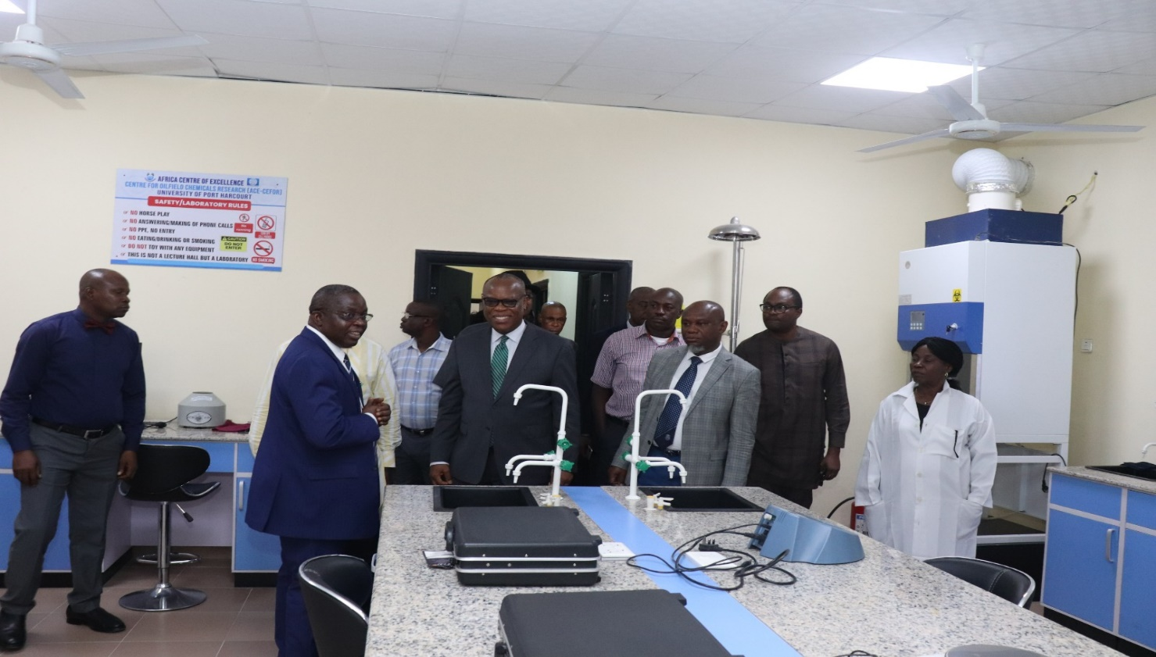
Inside the Engineering laboratory

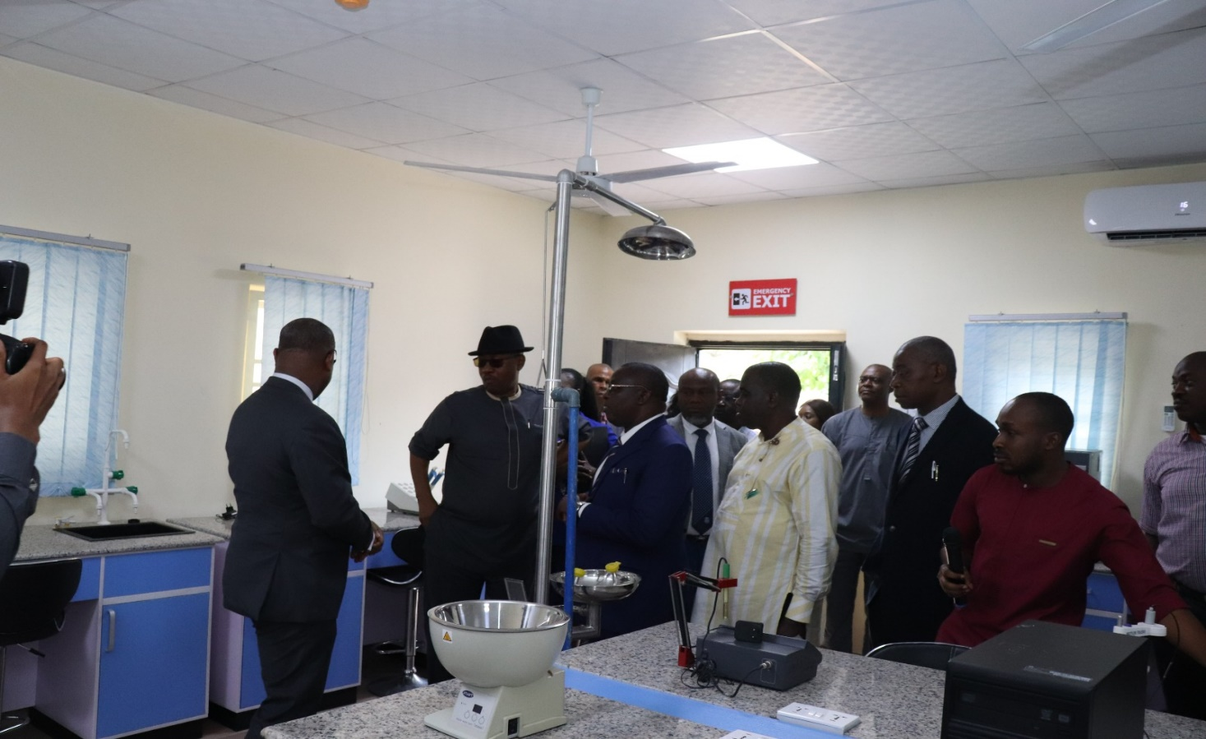
Inside the Science Laboratory
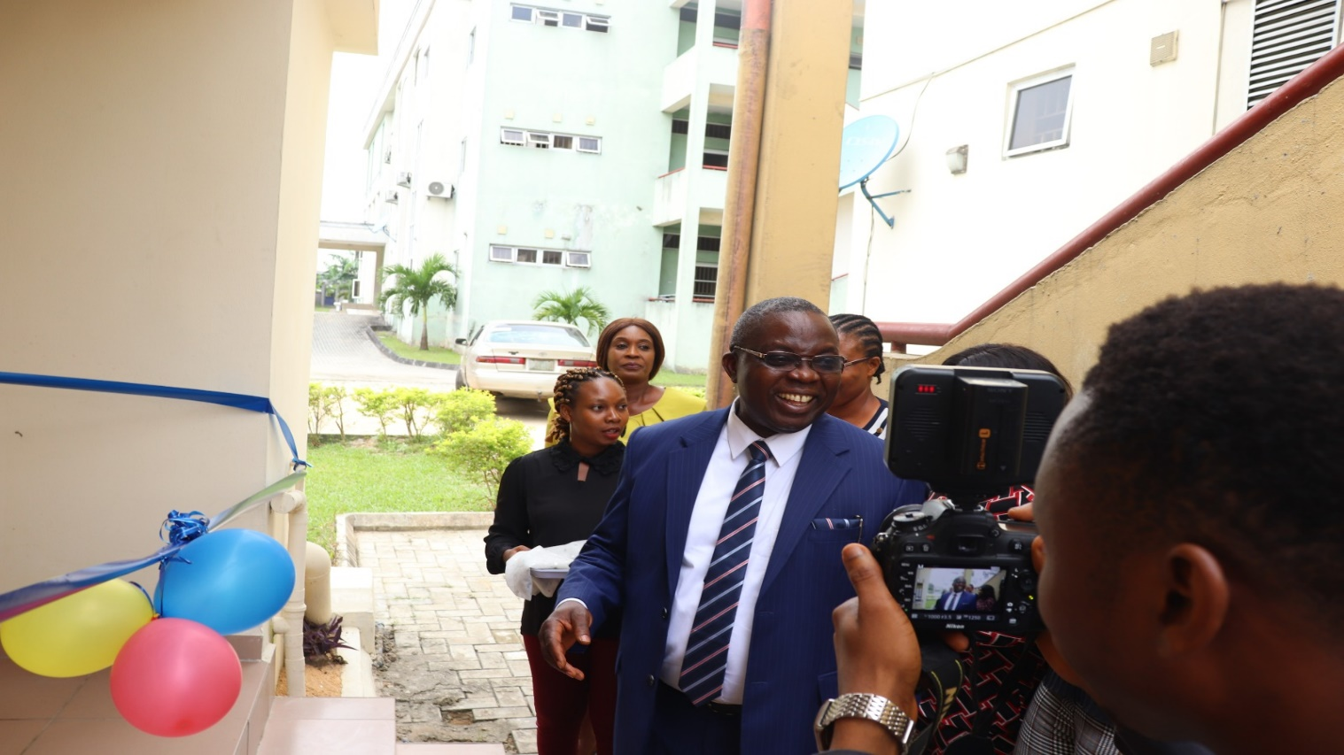Opening of the baby friendly Centre

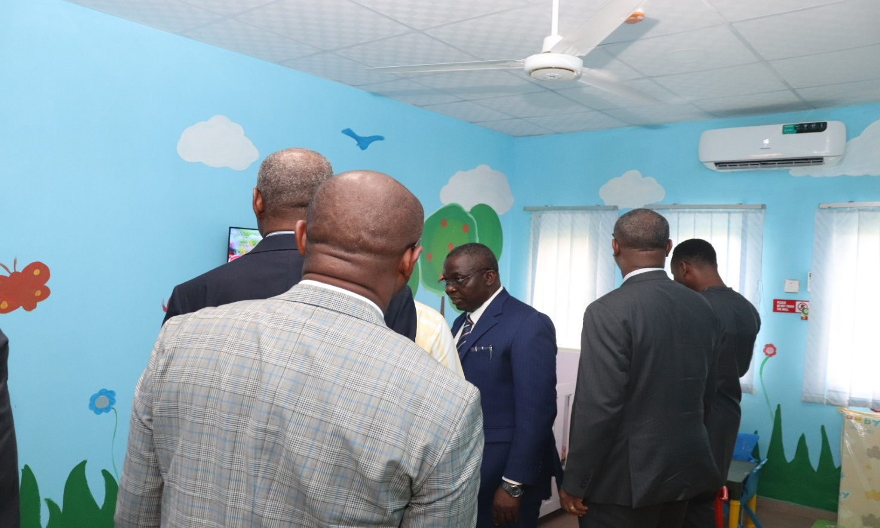 Inside the Baby friendly Centre

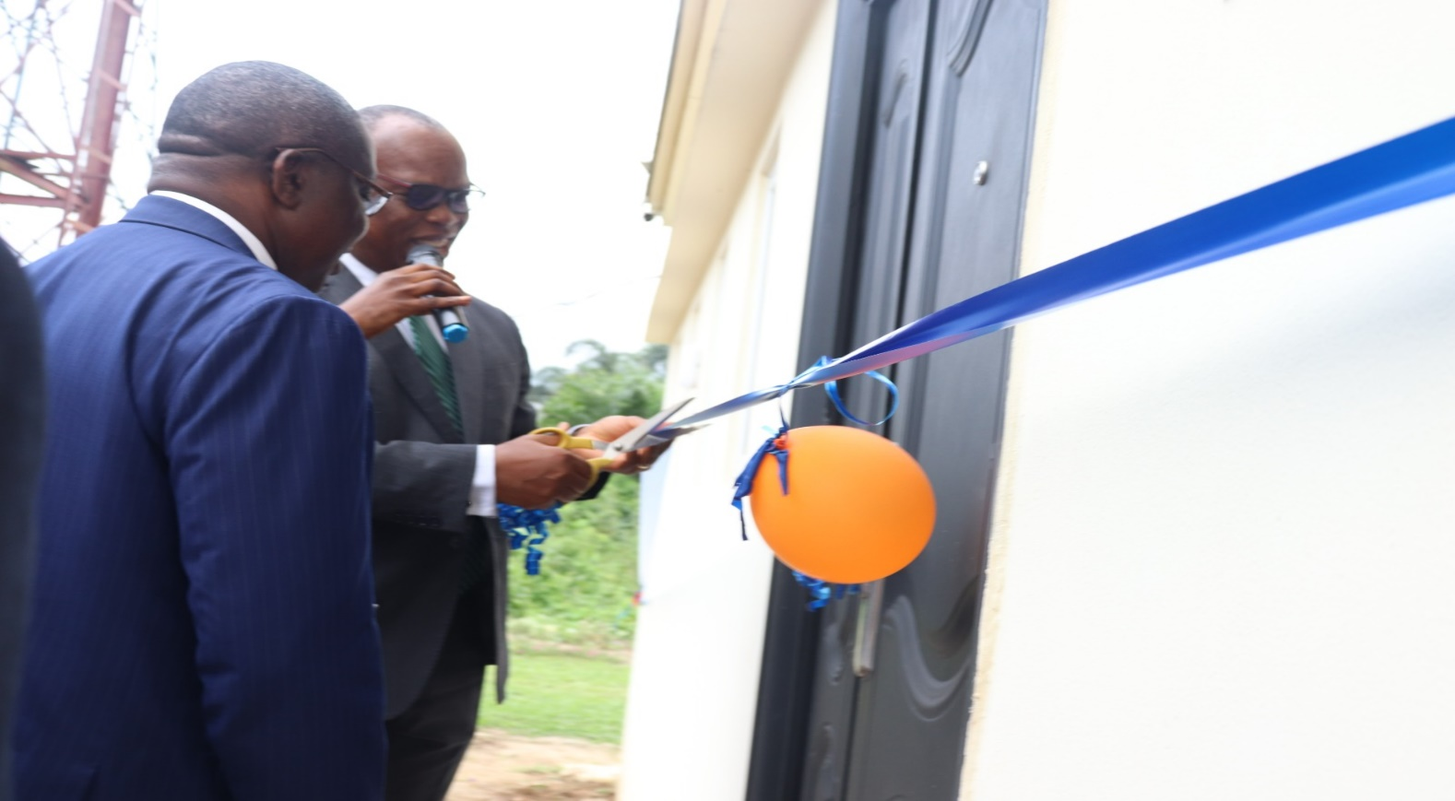
DVC R&D opening the Canteen
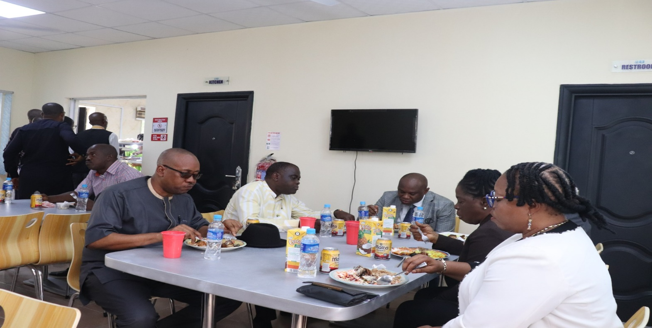
A time to unwind after the opening

